Science Fiction and Fantasy
Ms. Kamrass
ekamrass@newpaltz.k12.ny.us
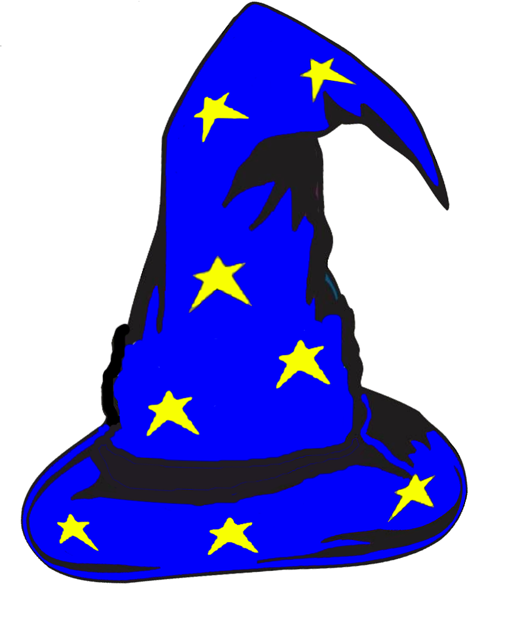
Overview:
This semester we will explore imaginative literature through different texts: literature, film, television, and our own writing. Throughout this time, we will read a variety of short stories, and some class novels. In addition, we will study several nonfiction companion pieces. Finally, we will discuss categories and attributes of both science fiction and fantasy literature.
While we will study these pieces within their genre, their respective genres by no means confine them: philosophy, horror, humanity, and humor intertwine in most of the texts we study.

Requirements:
- Reading, mostly completed in class with selected short stories
- Class work and homework (your main homework is to read most of The Hobbit outside of class, but you mostly complete this by managing your own time).
- Reading and film quizzes
- Writing and special projects
- Each student will bring in either one non-fiction science article, present a real-life scientific research video, or relevant subject on Ted Talks and present it to the class. This will help us brainstorm for class project ideas.

Important note about work:
If you complete all of you work and submit it on time, you should have no trouble excelling in this class. I try to work in lab time for you to complete the work, and most assignments are designed to be fun as well as enlightening. You will complete a variety of work: creative writing, critical writing, reading questions, quizzes and tests. There is a final exam in June.
The late-work policy for the English department is a ten-point deduction for each day an assignment is late. After five days I will no longer accept a late assignment (both A and B days count). You have a week to make up missed exams and quizzes – remember to check the weekly sheets if you are absent, and check with me (there often are changes and it is up to you to discover them).
Avoid plagiarism – For you to learn best, it is essential that you complete your own work and use proper MLA documentation when needed.

Grade breakdown: * Needed materials:
Writing assignments and projects– 50-100 points 3-ring binder
Short quizzes – 10-30 points pens
Exams and long quizzes – 50-100 points loose leaf (lined) paper
Homework and class work– 5-20 points
Participation – 10 points
*All points are per assignment
Descriptions of possible course projects:
Teenagers of the Future – Think about what you and your friends are like now; then think about what will change for teenagers in the decades to come. For this assignment, you will create a project that illustrates what teenage life will be like. Think about the technology now and what it will be in the future. More importantly, come to conclusions about how this future technology will influence teens (or will teens influence technology?).

The Robot Project – This is exactly what it sounds like. Robots are standard for science fiction, but why? What purpose do they serve? What does their creation – both real and imaginative – say about the humans who create them? You will write a product description and create a sketch, or a model.

Science Fact to Science Fiction – For this assignment, rely on the articles and science-fact video clips from class. Base your story on current trends in research; decide what the outcome will be for people because of this research. Choose some aspect of what we’ve read, or seen, and write a creative story based on the technology that we are currently developing.

Unexplained Phenomena or Mythological Beast Presentation – You will choose a topic and present with a partner. A handout will give you a list of choices.

Fantasy creative story – Using the common elements found in this genre, create your own story.

January 2020

Dear Parent(s) or Guardian(s):

Your child is enrolled in the Science Fiction and Fantasy, an English elective. In addition to the required literature, we will analyze recurring themes and categories of literature and science fiction through film. We will view a number of films during class, and some of these movies are rated R. The following is a list of films shown in past years; there may be some additions. We do not have time to watch all of them.

Elysium Children of Men
Star Wars and/or The Empire Strikes Back Planet of the Apes (original)
Alien any one of the Harry Potter series
The Terminator any one of the Lord of the Rings trilogy
Thor any one of the Hobbit films
Galaxy Quest the new Star Wars
Mars Attacks!
The Matrix

In order for your child to partake in these lessons, please sign in the space below. If you have any questions or concerns, please contact me at ekamrass@newpaltz.k12.ny.us.

Thank you.

Sincerely,

Eileen Kamrass
New Paltz High School English teacher

I give my child, _________________________________, permission to view the films for the
Science Fiction and Fantasy curriculum.

Signed ________________________________________ date __________________

